Comprehensive Final Project Report
CP8305 - Knowledge Discovery
Alec De Sousa (500918882)
alec.desousa@torontomu.ca
Hermes Hui (500763595)
hchui@torontomu.ca
April 3rd, 2026

Abstract
Canada’s real estate market is one of the most expansive and diverse in the world, globally encompassing residential, commercial, industrial, and agricultural properties. In recent years, shifting economic conditions have significantly altered mortgage requirements and borrowing capacities compared to those of the past five years. These changes have introduced increased uncertainty for both buyers seeking optimal purchase prices, and sellers aiming to maximize returns.
This study presents a data-driven approach to support decision-making for real estate brokers, homeowners, and prospective buyers. Using residential property data collected by Yuliia Bulana [1] from Remax in February 2025, we applied k-means clustering to identify distinct market segments, association rule mining to uncover relationships between property features and pricing patterns, and a random forest model to predict property price ranges. The proposed framework provides interpretable insights into pricing dynamics, enabling stakeholders to make more informed and strategic real estate decisions.

Introduction
The Ontario housing market is one of the most complicated, volatile, and diverse in North America; from high-density urban condominiums in the Greater Toronto Area, to expansive rural estates in Northern Ontario. This diversity creates a complex data landscape that many traditional linear models struggle to capture. Some of the frequently used real estate analysis techniques currently available overrely on price-point regression. We wanted to explore more towards understanding the market based on classifying properties based on their structural characteristics such as finished basement or sewage infrastructure to dictate what property type is present.
We approached our problem based on the residential property data collected by Bulana [1] from Remax in February 2025. This dataset consists of 29,194 Ontario listings, with 29 distinct attributes. It provided the opportunity for higher-dimensional exploration, moving past simple price-per-square feet metrics.
We approached the problem through a multi-tiered hybrid methodology to reduce the complexity of the data. We began by using an unsupervised K-means clustering to determine natural market segments. Then we conducted Association Rule mining to extract the logic that defined each segment. And finally, we created a Random Forest model to conduct the final classification. This model consists of an ensemble of decision trees that handle non-linear relationships and have an inherent robustness against the noise found in the data inputted by the realtors.
The goal of this classification system is to provide a transparent, readable, and intuitive rule-based framework to categorize residential property listings in Ontario.

Data

K-Means Clustering
K-means clustering only works with numeric data, so only the numeric attributes will be used. However, the property's square footage (stored as a string) would be useful to determine the size of the property, so that data was converted into numeric form. This was done by cleaning the data (removing characters and spaces), and then converting the leftover data (numbers in string form) into a numeric attribute. Once that was completed, an additional attribute was created to list the price per square footage of the property.
Now that the relevant attributes were in numeric form, some slight data cleaning was conducted. First, missing values were dropped from the data. It was at this point where an unfortunate realization emerged. The attribute containing square footage was empty for the vast majority of data. By dropping missing values, the effective dataset was reduced from 29,579 instances to 2,261 instances. Some information found online suggested filling in the missing data with the median, but that would heavily skew the overall results. So, a compromise was found. Two datasets would be created; first, a smaller one consisting of 2,261 instances that included the property’s square footage. And second, a bigger one consisting of 26,890 instances that only included the price, and the number of bedrooms and bathrooms. From there, an outlier from each dataset was removed. The smaller dataset removed the most expensive property due to being double the price of the next most expensive ($22M vs $10M). The larger dataset removed the highest bedroom count, also due to being (nearly) double the next highest (68 rooms vs. 38 rooms). Scatterplot graphs were generated later, so these outliers were removed to maintain readability. Though, these outliers could also skew the overall results of the model.
Finally, the data was scaled, which is imperative for k-means clustering. K-means clustering determines clusters based on Euclidean distance, which means large numerical ranges greatly influence the clusters. By scaling the data, the ranges are converted into a range between 0 and 1. This would prevent, say, price (ranges between thousands to millions) from completely overpowering an attribute like baths (ranges from 0-4).

Association Rules
Unlike k-means clustering, association rules require categorical attributes rather than numerical. Due to this, the numerical attributes used in k-means clustering were converted into categorical attributes. This was done by creating 3 bins for each attribute, labeled “low”, “med”, and “high”. These bins had different cut-offs for each attribute, depending on the attribute (i.e., 4 bathrooms is “high”, but 4 bedrooms is “med”).
Beyond that, the addressLocality attribute required some cleaning before it could be used. Because there were variations of the same locality throughout the dataset ("Thunder Bay" and "THUNDER BAY", or "Ajax (Central East)" and "Ajax (Central West)"), these localities were merged together. The reason for this lies with the way association rules are generated. If there’s too many options with sparse data, it translates to very weak rules. To circumvent this, these localities were grouped together. Furthermore, only the top 10 most common localities were used, all other localities were grouped under the label “Other”.
With the previous steps completed, a dataset of the converted numerical attributes, grouped localities, k-means clusters, and relevant categorical attributes, was created and encoded.

Random Forest
Before creating the random forest, we began with dropping any of the rows that have the cluster label missing. We wanted to ensure that the previous data preprocessing steps have provided the dataset only valid samples. We then provided the model with features selected for physical property characteristics rather than the administrative data like MLS numbers. We wanted to focus more on what physical features push a specific property into a cluster rather than the price point or square footage.
We used one-hot encoding to convert the categorical text data into numerical binary columns (through pd.get_dummies()). We used the drop_first = True parameter to prevent multicollinearity or the dummy variable trap. We enforced a data type standardization through explicitly casting the target clusters to integers. This prevented the classifier from accidentally treating our cluster labels as continuous numeric values.
Finally, we decided to use a stratified train test split where a test set of 15% would be created. We wanted to ensure stratification was present so each housing cluster is proportionally represented in the training and testing sets. This reduces the impact that luxury estates or other outliers would have on the training and testing data.

Model

K-Means Clustering
Now that the data is scaled, the k-value needs to be determined. To do this, k-values from 1 to 10 were graphed using the elbow method with corresponding inertia values [6].
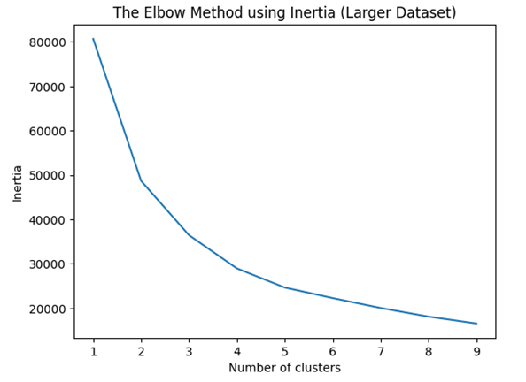
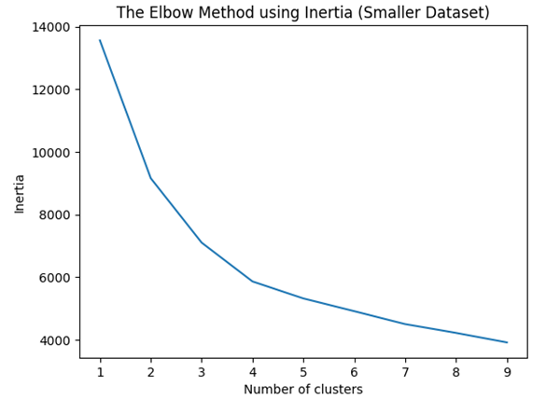
Using the elbow method, the optimal k-value is found at the point where the improvement slows down [6]. From the graph, the optimal k-value is likely between 2 and 4. To determine which is more optimal, the silhouette score for each k was calculated.
 | Smaller Dataset | Larger Dataset
K-Value | Silhouette Score
K = 2 | 0.3494088712259932 | 0.48395953927574265
K = 3 | 0.33976543966177125 | 0.45847778673449335
K = 4 | 0.3212048695206462 | 0.41355569283082505

When comparing silhouette scores, the higher score is more optimal. In this scenario, a k-value of 2 is the most optimal. However, a k-value of 3 would provide more options for a prospective home buyer, and fit the business goals for the data better. Therefore, while technically sub-optimal, k = 3 was chosen for both datasets.
With k established, k-means clustering was finally performed on the dataset. Once completed, a number of graphs and tables were created to provide insight on the dataset.
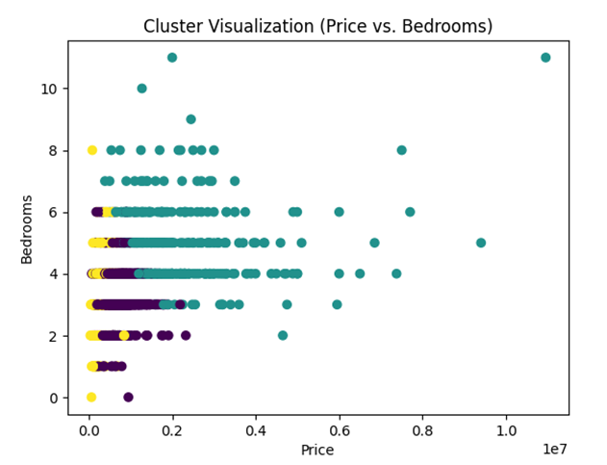
Smaller Dataset:
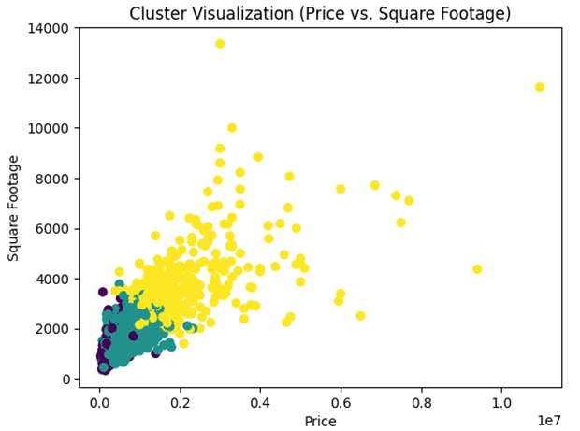
Clusters by Mean
Cluster | Price | Bedrooms | Bathrooms | Square Footage | Bathtubs | Price per Sqft
0 | $755K | 3.1 | 2.8 | 1690 | 1 | $456
1 | $2.07M | 4.8 | 4.4 | 3763 | 1.1 | $564
2 | $376K | 3.1 | 1.7 | 1296 | 0 | $292

Clusters by Median
Cluster | Price | Bedrooms | Bathrooms | Square Footage | Bathtubs | Price per Sqft
0 | $720K | 3 | 3 | 1595 | 1 | $451
1 | $1.70M | 5 | 4 | 3450 | 1 | $493
2 | $325K | 3 | 2 | 1184 | 0 | $280

Cluster by Variation (Scaled Data)
Bathtubs | 1.200561
Bathrooms | 1.145621
Square Footage | 1.136243
Price | 1.073052
Bedrooms | 0.858088
Price per Sqft | 0.676522

Larger Dataset:
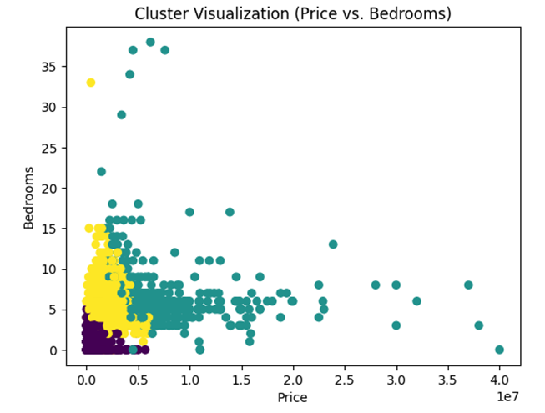
Clusters by Mean
Cluster | Price | Bedrooms | Bathrooms
0 | $685K | 2.4 | 1.8
1 | $6.97M | 6.3 | 6.9
2 | $1.49M | 4.7 | 3.8

Clusters by Median
Cluster | Price | Bedrooms | Bathrooms
0 | $635K | 2 | 2
1 | $5.50M | 6 | 7
2 | $1.28M | 4 | 4

Cluster by Variation (Scaled Data)
Price | 2.664251
Bathrooms | 1.748679
Bedrooms | 1.190568

The clusters by mean and median tables provide insight on the real world data. The cluster by variation (scaled data) table, on the other hand, describes which attributes have the most influence on the cluster’s generation. In the smaller dataset, bathtubs and bathrooms have the most influence. In the larger dataset, price has the most influence.

Association Rules
With the preprocessing steps completed, the Apriori algorithm is applied to identify frequent itemsets that appear in at least 19% of the dataset (19% was a sweet spot found via trial and error). From these itemsets, association rules are generated using a minimum confidence of 0.8, ensuring only strong and reliable relationships are retained. Finally, the top 10 rules are printed in a readable form.

Association Rules
IF Bathtubs = Low AND Sewer = Sanitary Sewer THEN Property Type = Single Family
IF Sewer = Sanitary Sewer AND Heating = Forced Air, Natural Gas THEN Property Type = Single Family
IF Sewer = Sanitary Sewer THEN Property Type = Single Family
IF Fireplace = Yes AND Price = High THEN Property Type = Single Family
IF Bathrooms = High THEN Property Type = Single Family
IF Sewer = Sanitary Sewer AND Property Type = Single Family THEN Heating = Forced Air, Natural Gas
IF Bathtubs = Low AND Fireplace = Yes THEN Property Type = Single Family
IF Heating = Forced Air, Natural Gas AND Fireplace = Yes THEN Property Type = Single Family
IF Sewer = Sanitary Sewer THEN Heating = Forced Air, Natural Gas
IF Sewer = Sanitary Sewer THEN Property Type = Single Family AND Heating = Forced Air, Natural Gas

Random Forest
Creating the random forest, we began by establishing the class_weight = ‘balanced’ parameter when creating our RandomForestClassifier. This allowed us to heavily penalize the model automatically for mistakes on the smaller clusters. This is vital for the Ontario data where the “upper class” homes and “lower class” homes (cluster 1 and cluster 2 respectively) might have reduced dataset sizes compared to the “middle class” homes or cluster 0.
Considering the target audience for the completed model (realtors, real estate brokers, potential homebuyers, and homesellers), we wanted to ensure that the trees were generic but have enough granular details to ensure that the model learnt general patterns about the Ontario housing market. We achieved this by setting the min_samples_leaf parameter to 5, providing enough flexibility for the model without it memorizing the individual listings.
We decided that the n_estimators should be 200, allowing the final classification to be the averaged result of 200 different decision trees. This allowed our model to significantly reduce the output variance.
Random Forest Confusion Matrix
106 | 54 | 34
7 | 45 | 10
4 | 4 | 75
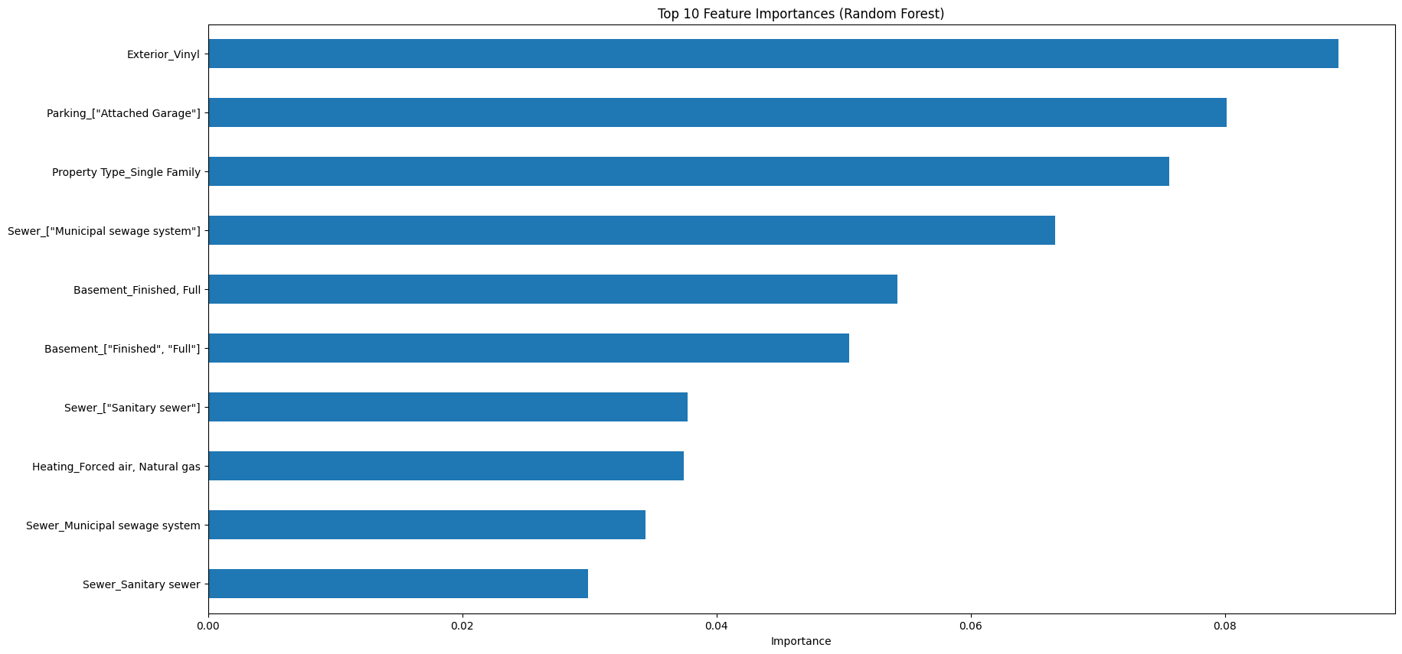
We evaluated our Random Forest model through some standard performance metrics including a confusion matrix and a classification report. This allowed us to verify which clusters the model struggled to classify (similar listings in certain price brackets). We also generated a global feature importance chart, where a horizontal bar chart shows the top ten features that were most influential across the entire model. Finally, we conducted SHAP analysis for local interpretability, where we explored how much each feature contributed to the assignment of a specific cluster. We achieved this through using shap.TreeExplainer on the model. For each cluster, we applied summary plots to understand how far each of the identified features pushed a listing towards a specific classification.

Analysis and Findings

K-Means Clustering

Smaller Dataset:
Cluster 0: This cluster represents “middle class” homes. Priced around $755,000, these properties typically feature 3 bedrooms and 2 or more bathrooms (often including at least 1 bathtub) and offer about 1,690 square feet of living space.
Cluster 1: This cluster represents “upper class” homes. With prices near $2,070,000, these houses generally include more than 4 bedrooms and bathrooms, often with multiple tubs. They are significantly larger than those in cluster 0, reaching roughly 3,763 square feet.
Cluster 2: This cluster represents “lower class” homes. Valued at approximately $325,000, these properties usually include 3 bedrooms and 1 to 2 bathrooms. They are the most compact, at about 1,296 square feet.
For a family with one child, cluster 0 or cluster 2 would work best. Cluster 2 would be optimal if the family had a lower income. On average, the number of bedrooms between cluster 0 and 2 are nearly identical. If the family wanted to have more children, and thus require more bedrooms, that would not affect their decision between cluster 0 and 2. Having said that, cluster 0 properties are typically larger than cluster 2, so that may factor into the parent’s decision.

Larger Dataset:
Cluster 0: This cluster represents “lower-middle class” homes. These houses are typically priced around $685,000 and include 2 to 3 bedrooms along with 1 to 2 bathrooms.
Cluster 1: This cluster represents “high-class”, luxury homes. With prices near $6,970,000, these properties often feature more than 6 bedrooms and 6 bathrooms, reflecting their expansive and extravagant nature.
Cluster 2: This cluster represents “upper-middle class” homes. Priced at roughly $1,490,000, these houses commonly include 4 to 5 bedrooms and 3 to 4 bathrooms.
For a family with one child, cluster 1 can immediately be omitted. Cluster 0 would be best for a family that does not want to expand much (as the homes usually only have 2 or 3 bedrooms). Additionally, if the family is middle class, they may find cluster 0 to be most affordable. On the other hand, if the family is wealthier, they may be able to afford cluster 2 homes. These homes typically contain 4 to 5 bedrooms as well, so if the family wants more children, or to live with grandparents, that option becomes open to them.
Visualization Comparison

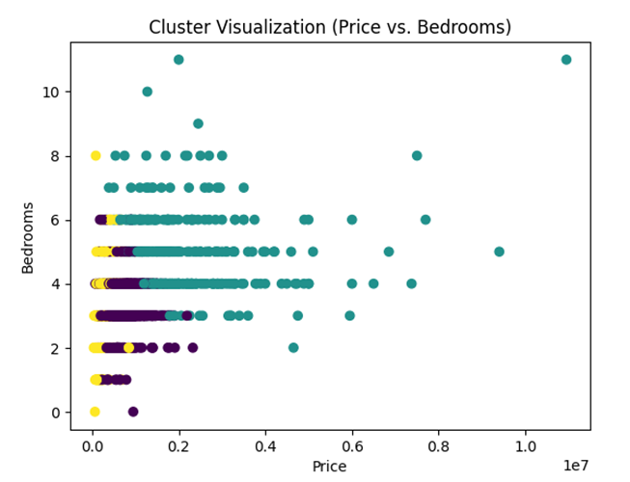
Price vs. Bedroom Cluster Visualization Comparison between Small Dataset (Left) and Large Dataset (Right)
It is difficult to compare the small and large datasets, as they only share 3 attributes. However, a trend between the two datasets is that there are rarely more than 10 bedrooms per home, regardless of the price of the property. Another interesting trend (that is more prevalent in the larger dataset), is how the properties with the most bedrooms tend to be at the lower end of price. And alternatively, how as price increases, bedroom counts stay roughly the same. Overall, this would suggest that the price of a property is not influenced by room count, but another attribute. One such attribute may be square footage, as seen in the cluster visualization graph of the smaller dataset (square footage increases with price).

Association Rules
The generated association rules reveal strong relationships between common residential features and homes for single families. In particular, sanitary sewers emerged as a highly predictive factor, implying with high confidence that properties with such a sewer system is a single family home. This relationship is further reinforced when combined with attributes such as forced air heating, the presence of fireplaces, higher price categories, and a greater number of bathrooms. Overall, the rules highlight clear patterns in the dataset, where typical residential characteristics strongly distinguish single family properties.

Random Forest
Random Forest Accuracy |  |  | 0.6666666666666666
Random Forest Classification Report
 | precision | recall | f1-score | support
0 | 0.91 | 0.55 | 0.68 | 194
1 | 0.44 | 0.73 | 0.55 | 62
2 | 0.63 | 0.90 | 0.74 | 83
accuracy |  |  | 0.67 | 339
Macro avg | 0.66 | 0.73 | 0.66 | 339
Weighted avg | 0.75 | 0.67 | 0.67 | 339

Our Random Forest model achieved an overall accuracy of 66.67% and a weighted average F1-score of 0.67. One problem we saw in the confusion matrix was the model’s tendency to misclassify cluster 0 (middle class) listing as cluster 1 (upper class), as 54 listings were misclassified. The model performed exceptionally well when identifying cluster 2 (lower class) listings as the model achieved a 0.90 recall but the model seems to use cluster 1 (upper class) as a “catch all” group for any listings it is uncertain about.
Our Random Forest model identified that the physical outer characteristics were the strongest predictors for classifying Ontario properties. Having exterior vinyl and an attached garage were the most influential factors at 8.8% and 8.0% respectively. Being a single family property type was also a strong predictor at 7.5%.
Through our SHAP summary plots, we understand more about what properties each cluster contains.
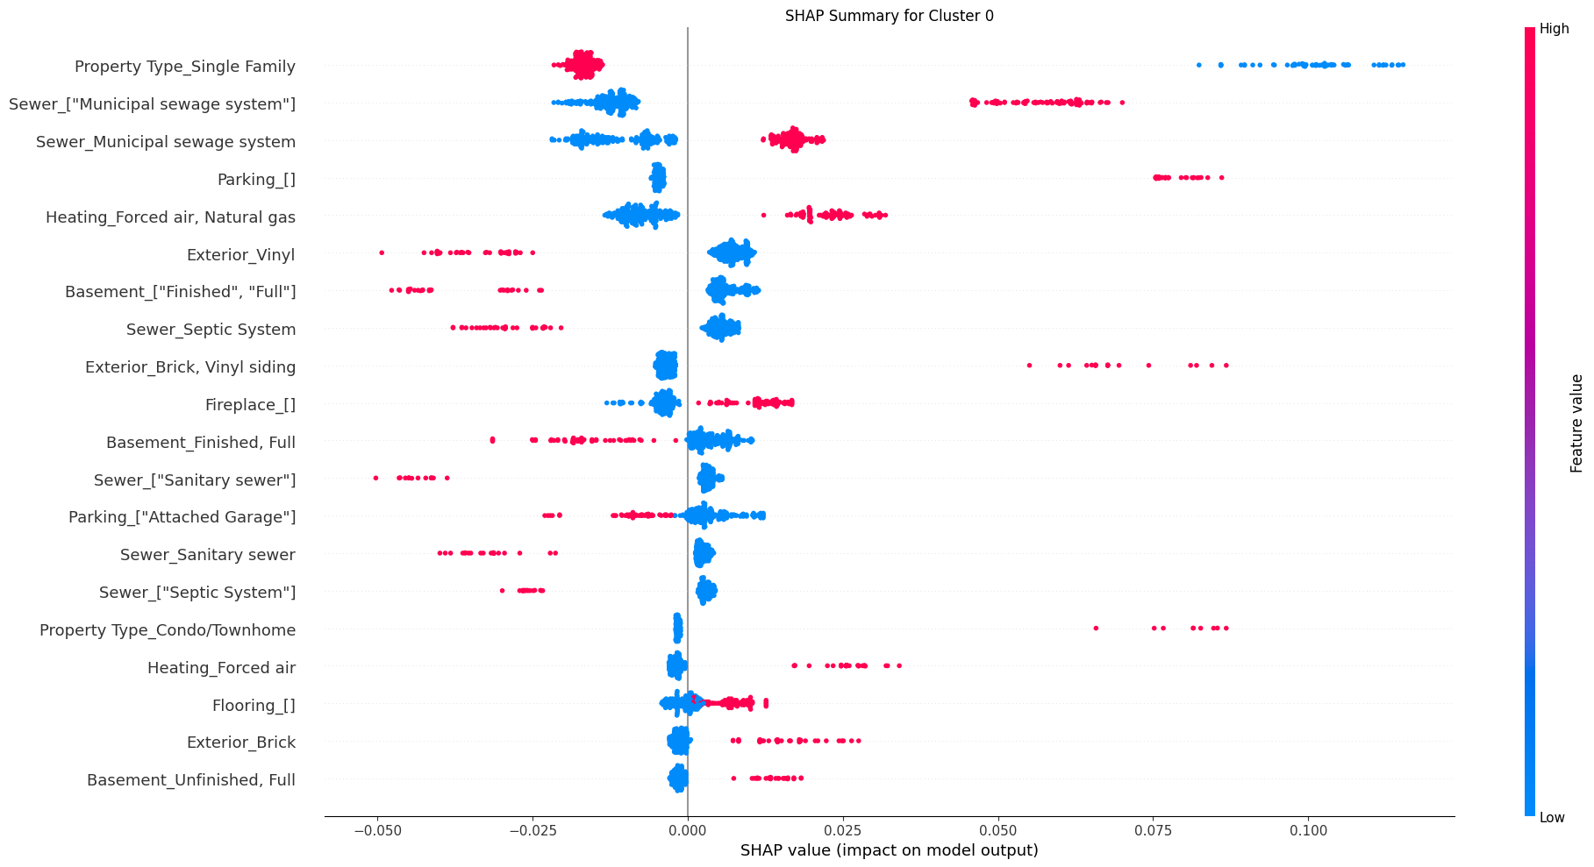
In Cluster 0 (middle class) summary plot, the single family property type was blue (low) and had a strong positive association with this cluster. This suggests that the cluster contains many condos, townhouse complexes, or multi-family units where the “single family” status is not present.
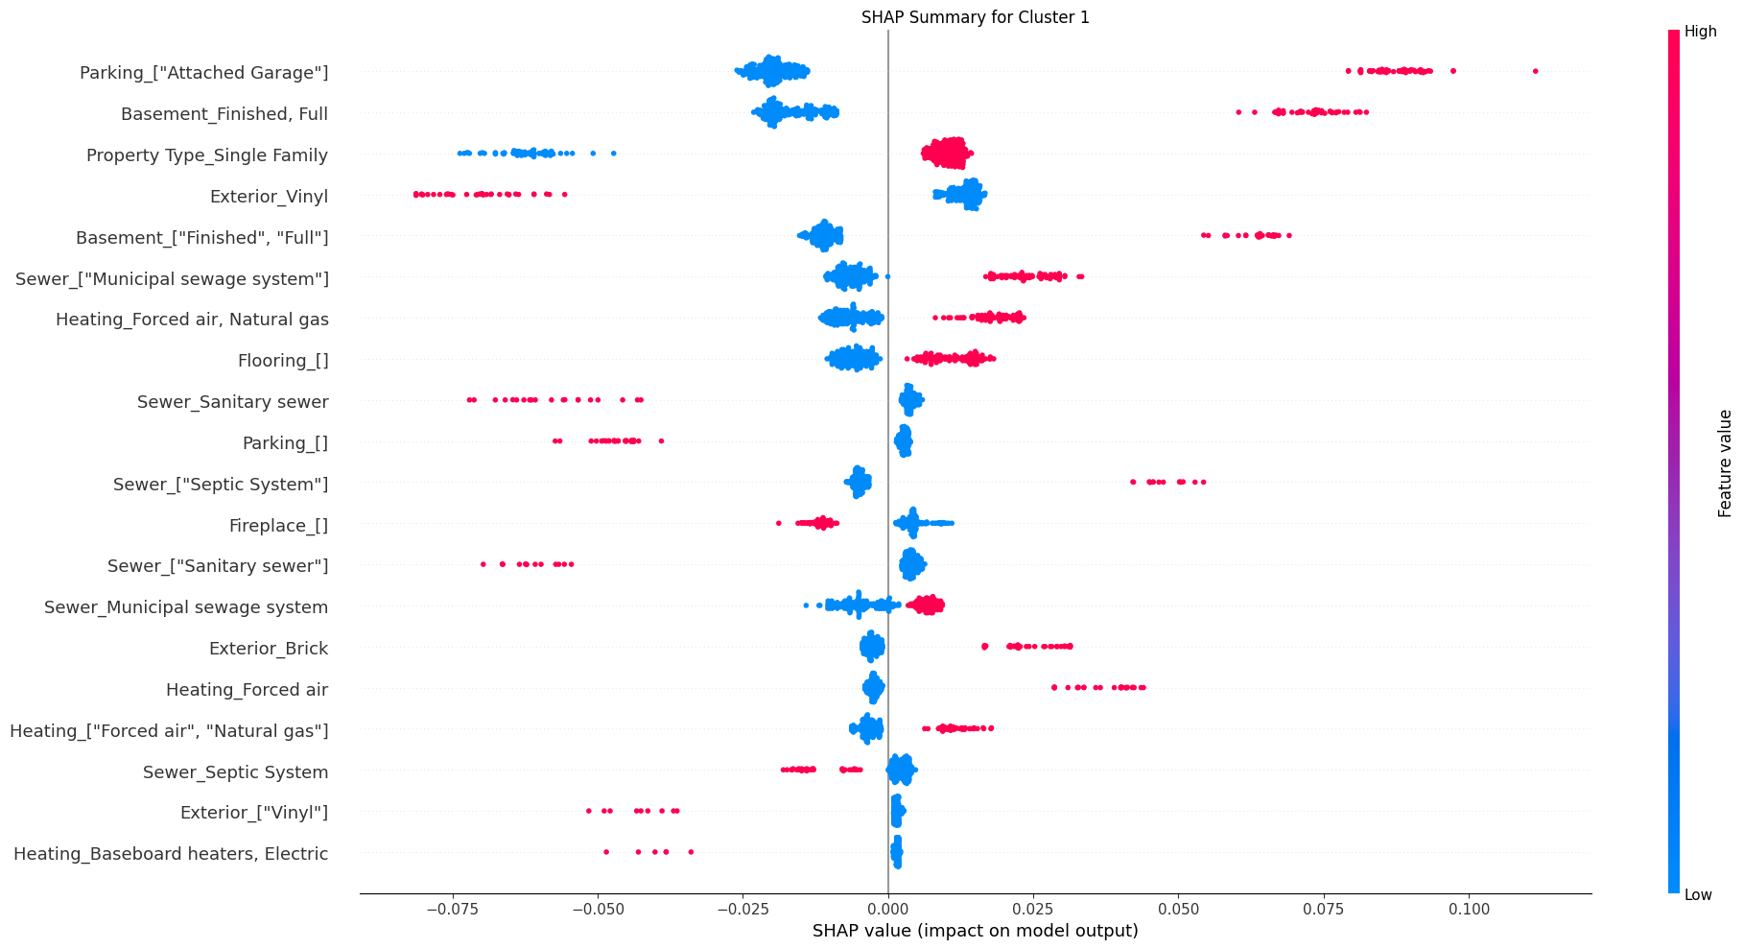
The Cluster 1 (upper class) SHAP summary plot showed high values for Parking_[‘Attahced Garage’] and Basement_[‘Finsihed’, ‘Full’], suggesting the two features as the strongest driving factors. This represents the suburban standard that many Ontario residents dream for (a finished basement and an attached garage).
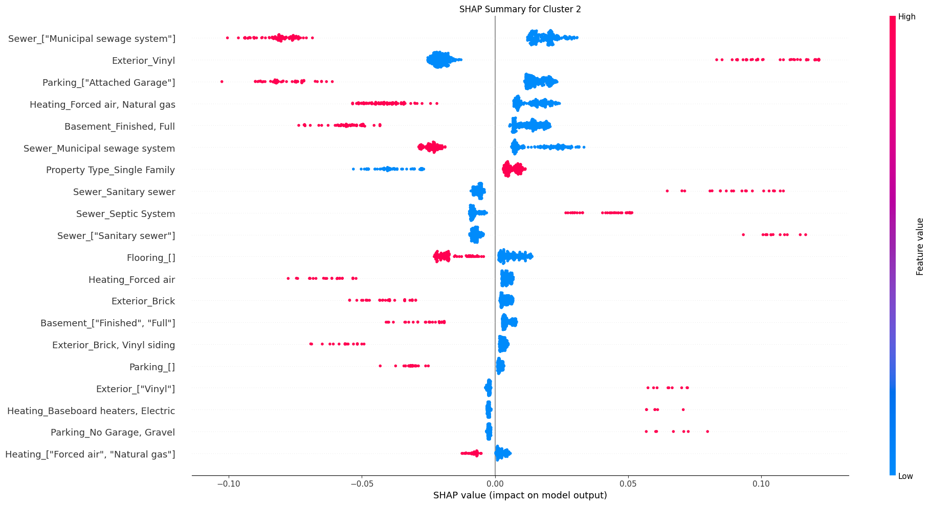
Finally, the Cluster 2 (lower class) summary plot Sewer_[‘Municipal sewage system’] being low (or blue) was a strong indicator of the cluster. This suggests that rural or semi-rural properties with septic tanks or older infrastructure with vinyl exterior are more likely to appear in this cluster.

Conclusion
This project developed a machine learning approach to better understand patterns within Ontario's residential housing market. By combining clustering, association rules, and random forest, properties were grouped into meaningful segments and relationships between physical features and housing types were uncovered. The results show that characteristics such as layout, infrastructure, and exterior features play a larger role in distinguishing properties than simple measurements like bedroom count. The random forest model achieved reasonable accuracy, demonstrating that these features can be used to predict market segments with moderate success.
These findings highlight the value of using machine learning methods to support real estate decision making. While the model performed well overall, improving data quality and incorporating additional factors such as local market conditions, or proximity to amenities, could strengthen future results. Expanding the approach with more advanced models may also improve predictive performance, making the framework more practical for real-world applications.
Finally, for reproducibility, the models were conducted on the following machines:
 | Machine 1 | Machine 2
Specifications | OS: Windows 10 Pro, Ver. 22H2, 64-bit  Processor: Intel Core i5-7300HQ  Memory: 16GB  Python: 3.14.3 | OS: macOS Tahoe 26.3.1 (a)  Processor: Apple M4 Pro  Memory: 24 GB  Python: 3.14.3

References
[1] Y. Bulana, "Canada Housing," Kaggle, 2025. [Online]. Available: https://www.kaggle.com/datasets/yuliiabulana/canada-housing. [Accessed: Mar. 17, 2026].
[2] J. Brannlund, H. Lao, M. MacIsaac, and J. Yang, “Predicting changes in Canadian housing markets with machine learning,” Bank of Canada Staff Discussion Paper, 2023. [Online]. Available: https://www.bankofcanada.ca/2023/09/staff-discussion-paper-2023-21/
[3] J. MacQueen, "Some methods for classification and analysis of multivariate observations," in Proc. 5th Berkeley Symp. Math. Statist. Prob., vol. 1, 1967, pp. 281–297.
[4] R. Agrawal, T. Imieliński, and A. Swami, "Mining association rules between sets of items in large databases," ACM SIGMOD Rec., vol. 22, no. 2, pp. 207–216, Jun. 1993. doi: 10.1145/170036.170072.
[5] L. Breiman, J. Friedman, R. Olshen, and C. Stone, Classification and Regression Trees. Belmont, CA, USA: Wadsworth International Group, 1984.
[6] GeeksforGeeks, "Elbow Method for Optimal Value of k in KMeans," Nov. 11, 2025. [Online]. Available: https://www.geeksforgeeks.org/machine-learning/elbow-method-for-optimal-value-of-k-in-kmeans/
[7] T. K. Ho, "Random decision forests," in Proc. 3rd Int. Conf. Doc. Anal. Recognit. (ICDAR), Montreal, QC, Canada, 1995, pp. 278–282.
[8] L. Breiman, "Random Forests," Mach. Learn., vol. 45, no. 1, pp. 5–32, 2001.

